Flutter
Flutter is an open-source UI (User Interface) software development kit (SDK) created by Google.It is used to build natively compiled applications for mobile (Android & iOS), web, desktop, and embedded devices from a single codebase.
The Core Problem it Solves: Traditionally, if you wanted an app on both Android and iOS, you had to write it twice: once in Kotlin/Java (Android) and once in Swift/Objective-C (iOS). Flutter allows you to write the code once and deploy it everywhere.

"Everything is a Widget"
In Flutter, the user interface is built entirely out of Widgets. A widget is a declaration of what the UI should look like.
- Structural elements (like a button or menu) are widgets.
- Stylistic elements (like a font or color scheme) are widgets.
- Layout aspects (like padding or centering) are also widgets.
Widgets nest inside each other to create a hierarchical structure called the Widget Tree.

The Two Core Types of Widgets:
- StatelessWidget:
  - Concept: Immutable. Their appearance cannot change while the app is running based on user behavior or data updates.
  - Examples: A static Text label, an Icon, or a company logo.
- StatefulWidget:
  - Concept: Dynamic. They maintain a "State" object that can change over time. When the state changes, the widget rebuilds itself to show the new data.
  - Examples: A slider, a checkbox, a counter button, or a text input field.

Key Feature: Hot Reload vs. Hot Restart
Flutter drastically speeds up development time with these two features:
- Hot Reload: Inject updated source code files into the running Dart Virtual Machine. It updates the UI in under a second without losing the app's current state (e.g., if you are 3 screens deep into testing a form, you won't get kicked back to the login page).
- Hot Restart: Fully restarts the app, destroying the current state and rebuilding the widget tree from scratch.

Dart Programming Language:

At the core of Flutter lies Dart, a modern and object-oriented programming language. Developed by Google, Dart offers a unique blend of simplicity, flexibility, and performance, making it an ideal companion for Flutter. With its strong typing and Just-in-Time (JIT) compilation, Dart provides an efficient development experience, enhancing productivity and enabling rapid iteration.
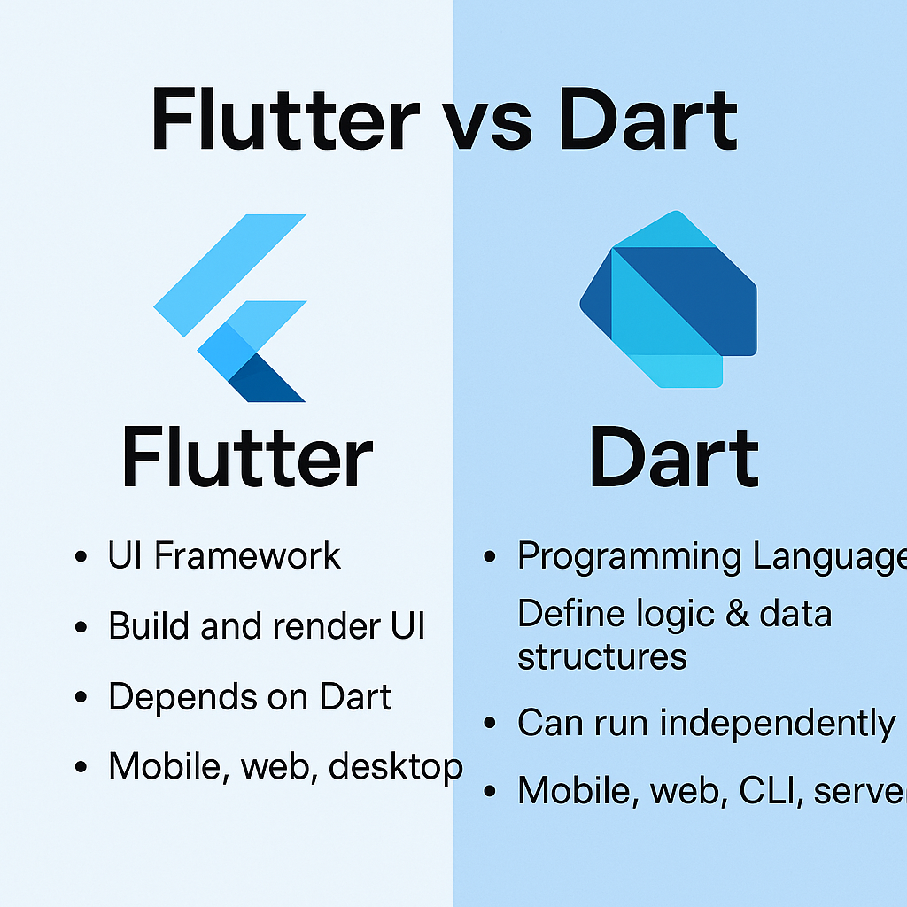

MaterialApp: The root widget that establishes the design scheme (Material Design) and configures navigation routes.
Scaffold: Provides a baseline structural layout for a mobile screen. It gives you ready-made properties for an appBar, a body, a floatingActionButton, and a navigation drawer.
Center: A layout widget that centers its child widget exactly in the middle of the available space.

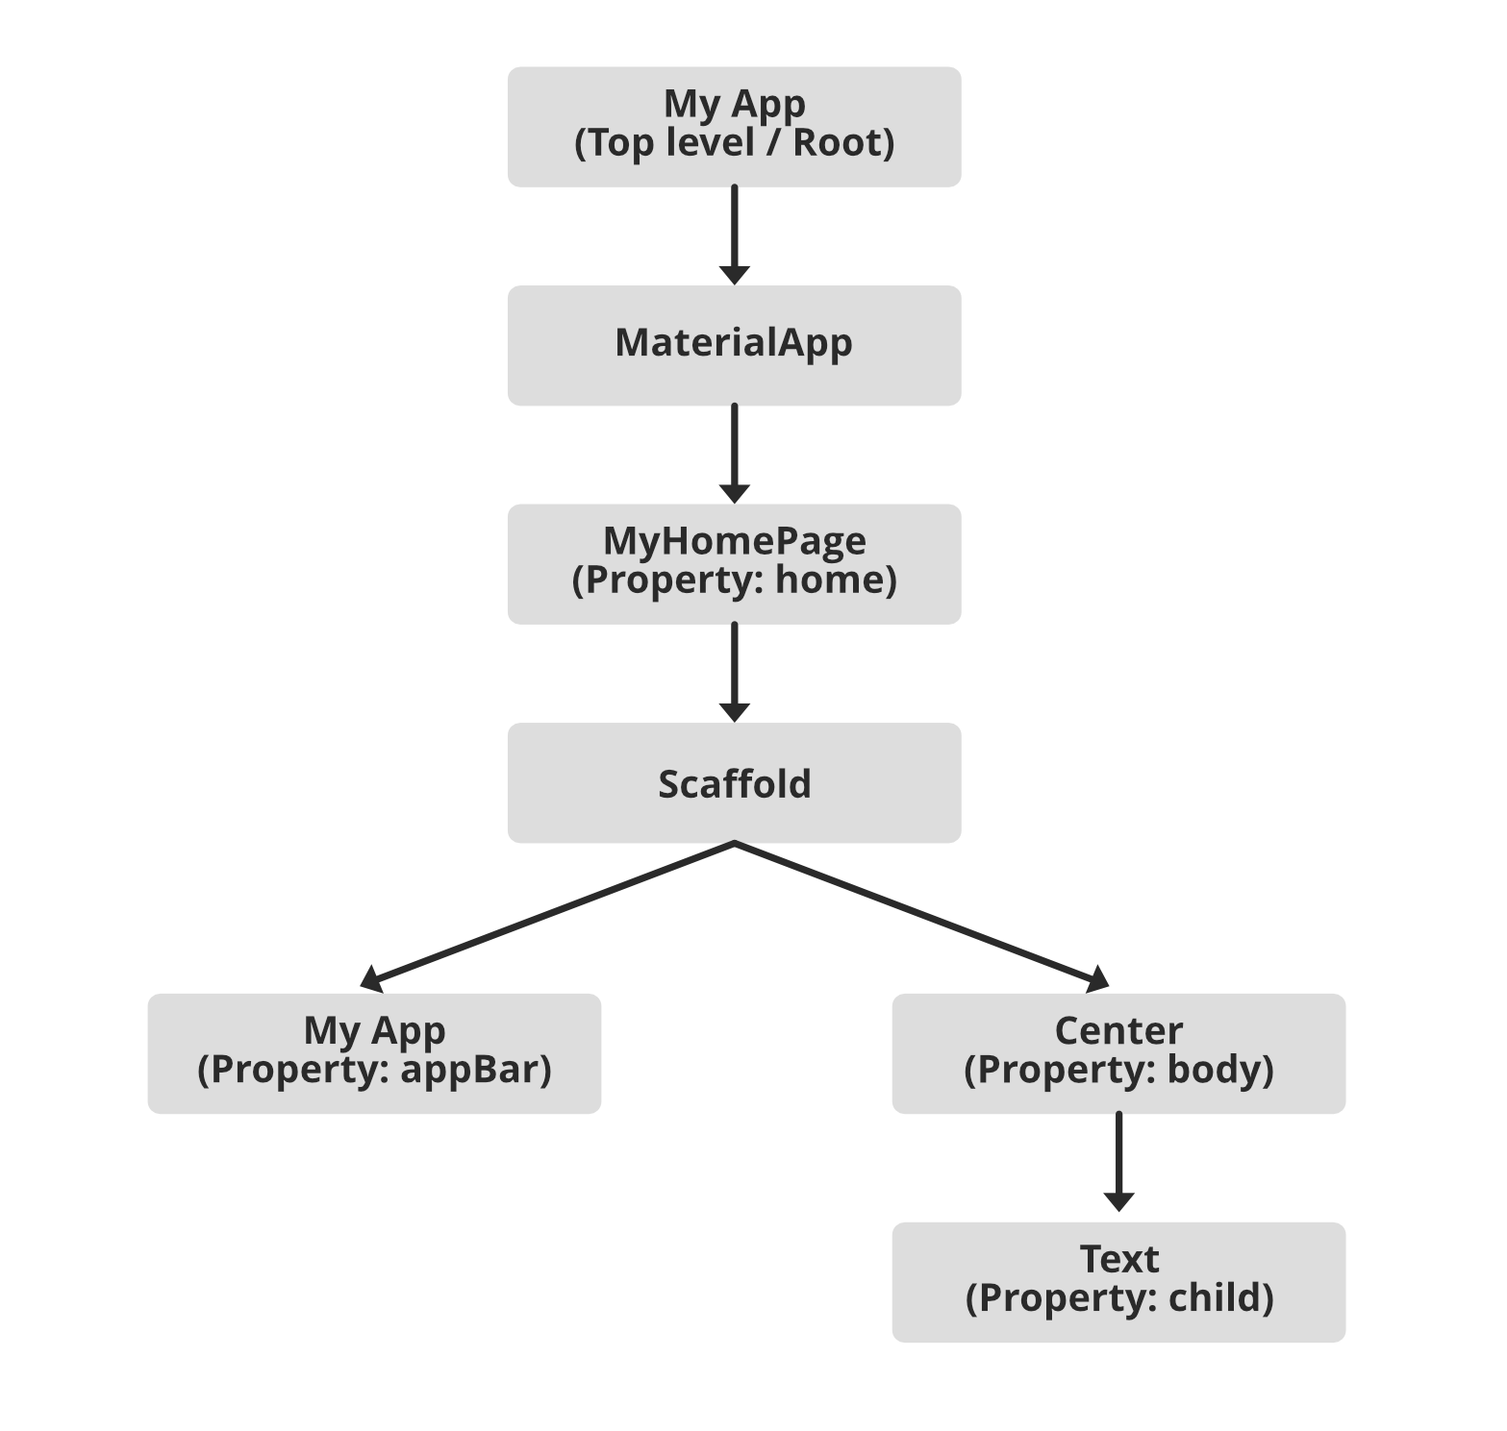
MaterialApp: The root widget that establishes the design scheme (Material Design) and configures navigation routes.
Scaffold: Provides a baseline structural layout for a mobile screen. It gives you ready-made properties for an appBar, a body, a floatingActionButton, and a navigation drawer.
Center: A layout widget that centers its child widget exactly in the middle of the available space.

Core Architecture & How it Works
Unlike traditional cross-platform frameworks, Flutter completely bypasses native platform UI components.
- Rendering Engine: Flutter uses its own graphics engine to draw every pixel, button, and text directly on the screen. This guarantees that your application looks exactly the same on an older Android phone as it does on the latest iPhone.
- Native Performance: Code compiles directly to native ARM machine code via Ahead-of-Time (AOT) compilation, allowing your application to achieve smooth, 60-to-120 frames-per-second performance.
- No Bridge Needed: Because it renders everything internally, there is no performance-draining communication bridge between your code and the host platform.

Advantages:
- Single Codebase: Saves time, effort, and cost by avoiding duplicate codebases.
- Native Performance: Compiles directly to native machine code.
- Rich Catalog of Widgets: Huge ecosystem of pre-designed widgets following Material Design (Google) and Cupertino (Apple) standards.
- Strong Community Support: Highly popular on GitHub and StackOverflow, backed heavily by Google.

Disadvantages:
- Larger File Sizes: Because the Flutter engine is bundled directly into the app package, the initial installation file (.apk or .ipa) is usually larger than a purely native app.
- New Language Barrier: Requires learning Dart instead of sticking to standard web tools (HTML/CSS) or native tools.
1) Install flutter and Dart sdk

To install Flutter and the Dart SDK, you can follow these steps:
a) Download Flutter: Visit the Flutter website's Get Started page and download the Flutter SDK for your
operating system (Windows, macOS, or Linux).
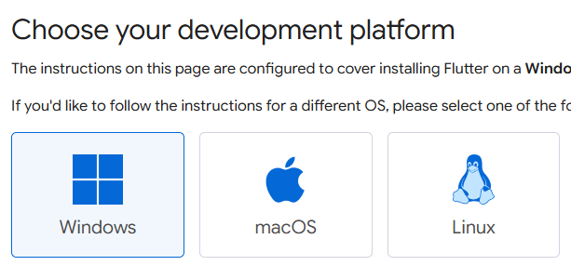

b) Extract the Flutter SDK: After downloading, extract the contents of the compressed file to a location on your computer where you want to store the Flutter SDK.
For example, you can extract it to C:\flutter on Windows, /Users/<your-username>/flutter on macOS, or ~/flutter on Linux.
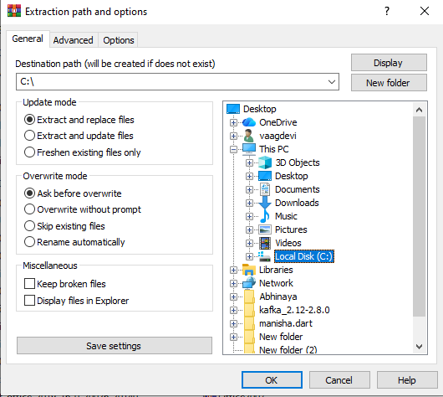
c) Add Flutter to your PATH: Update your system's PATH variable to include the Flutter bin directory.
This step allows you to execute Flutter commands from any directory in your terminal or command prompt.

The precise steps for updating the PATH vary depending on your operating system.

Windows: From the Start search bar, type 'env' and select 'Edit the system environment variables'.
Click on 'Environment Variables'. Under 'System Variables', find the 'Path' variable, select it, and click 'Edit'.
Click 'New' and add the path to the bin directory inside the Flutter directory (e.g., C:\flutter\bin).
Click 'OK' on all open dialogs to save your changes.
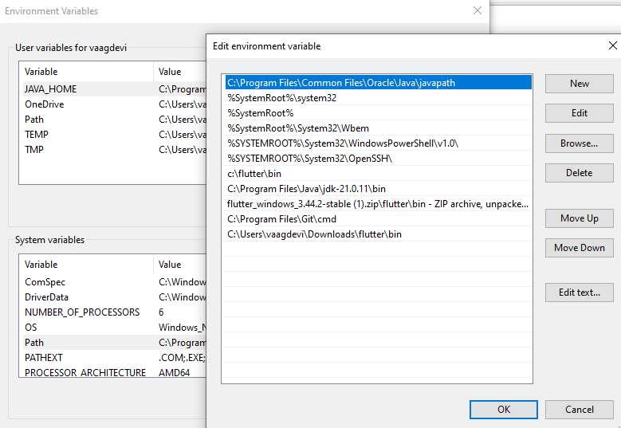
macOS and Linux:
Open a terminal window.
Run the following command to open the profile file associated with your terminal (.bash_profile, .bashrc, .zshrc, or similar):
nano ~/.bash_profile Add the following line at the end of the file: export PATH="$PATH:/path/to/flutter/bin"
Press Ctrl + X to exit, then Y to save changes, and Enter to confirm.

d) Verify the Flutter installation:
Open a new terminal window, and run the following command to verify that Flutter is properly installed:

flutter --version
This command should display the Flutter version and other relevant information if the installation was successful.
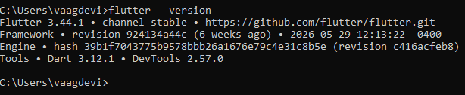
e) Install Flutter dependencies: Depending on your development environment, you may need to install additional dependencies,
such as Android Studio to fully set up your Flutter development environment.
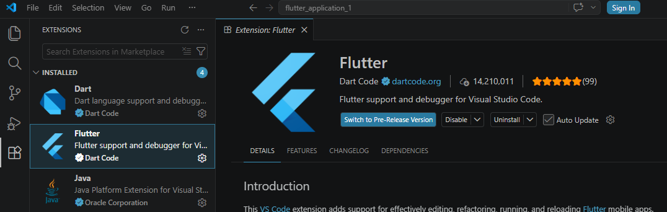
f) Download Dart SDK (if not bundled with Flutter):
Flutter comes with the Dart SDK bundled, so if you've installed Flutter, you should have the Dart SDK as well.
However, if you need to install Dart separately, you can download it from the Dart "SDK archive".

b) Write a simple dart program to understand the language basics

// Define a main function, which is the entry point of a Dart program.
void main() {
// Variables and data types
int myNumber = 10;
double myDouble = 3.14;
String myString = 'Hello World';
bool myBool = true;
// Printing variables
print('My number is: $myNumber');
print('My double is: $myDouble');
print('My string is: $myString');
print('My boolean is: $myBool');
// Basic arithmetic operations
int result = myNumber + 5;
print('Result of addition: $result');
// Conditional statements
if (myBool)
{
print('myBool is true');
}
else
{
print('myBool is false');
}
// Loops
for (int i = 0; i< 5; i++)
{
print('Iteration $i');
}
// Lists
List<int> numbers = [1, 2, 3, 4, 5];
print('First element of the list: ${numbers[0]}');
print('Length of the list: ${numbers.length}');
// Maps
Map<String, int> ages = { 'Kiran': 30, 'Raj': 25, 'Alekya': 35, };
print('Kiran\'s age: ${ages['Kiran']}');
}

OUTPUT:
